 | Chapter 7 Kuali Enterprise Workflow
 | The KFS utilizes a module called Kuali Enterprise Workflow (KEW), which handles the routing of electronic documents for actions such as approvals. Although much of its functionality works behind the scenes, the Action List, Doc Search and Workflow Services action buttons on the KFS menu bar are a part of KEW. For administrators, several configuration and maintenance options are available to control the flow of KFS work. To best understand this chapter, you should be familiar with the approval and workflow routing discussions in Chapter 2, Kuali Overview.
Topics |  | Introduction 7-103  Route Levels 7-103  Routing Rules 7-103  Route Status 7-103  Rule Templates and Attributes 7-103  KEW Operations 7-103  Document Search 7-103

Introduction
Kuali Enterprise Workflow (KEW) is a general-purpose, content-based electronic routing infrastructure or workflow engine. It is primarily used to automate the routing of electronic documents (e-docs) to individuals and workgroups for approval, although it can also be used to orchestrate complex processes between business components and applications. Approval routing is based on University or departmental business rules and policies.
Through the use of a centralized workflow engine, you can access and search for many types of e-docs from various functional areas from a single location via your Action List and Doc Search. The Route Log allows you to follow the progress of given documents through the approval process. Routing Reports allow you to view the projected routing of a document with a particular set of data or attributes.
For information about basic workflow, see "Error: Reference source not found” in Chapter 2, page Error: Reference source not found.

Overview
The Workflow Services screen, accessible by clicking the workflow services menu bar button from any KFS screen, is comprised of two main sections:
- Menu: Along the left column of the screen, is a list of underlined links that control what content appears on the right of the screen in the Work area section.
- Work area: Depending on the menu item selected, this section of the Workflow Services screen typically contains search criteria and selection tools (lookups, text boxes, search/clear buttons, etc.) on the top portion of the screen; with search results list tables on the bottom portion of the screen.
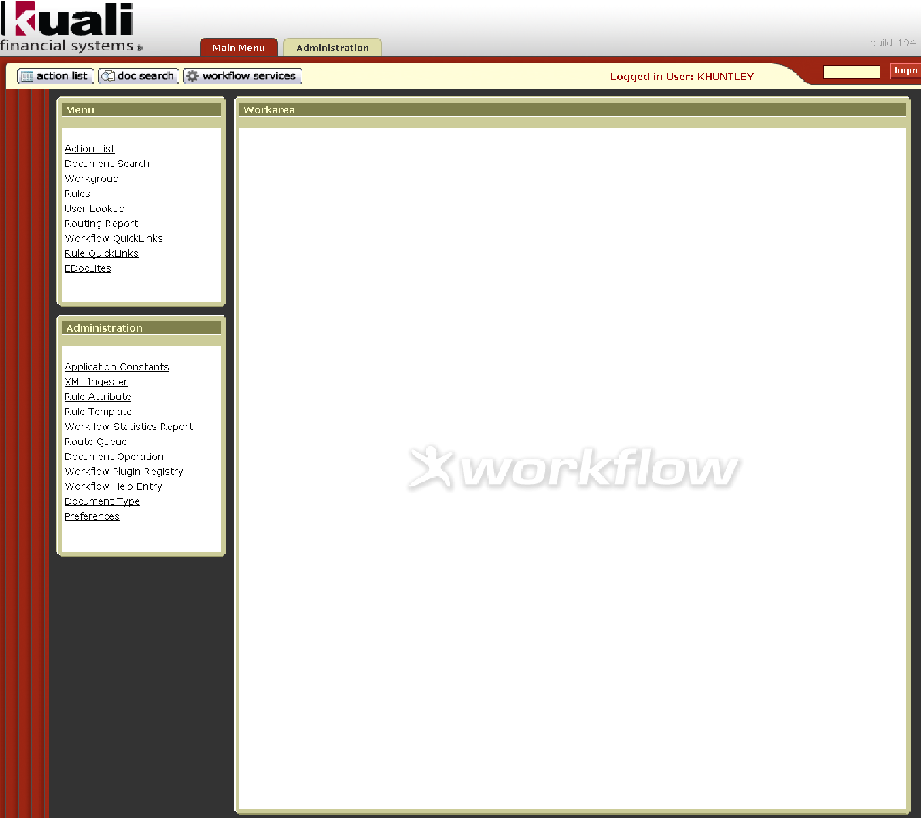
Workarea
Menu Groups
Workflow Services Buttons
Figure 7-1 Workflow Services Screen

Menu Group
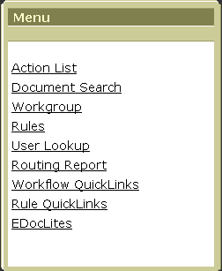
Figure 7-2 Menu Group
Table 7-1 Menu Group
Menu | Description
Action List | Same as Action List menu bar button. Table of e-docs waiting for you to take action on. Drilldown links allow access to content (with action buttons), user, and route information.
Document Search | Same as Doc Search menu bar button. Search for e-docs using a variety of search tools, including text boxes, date selection and lookups.
Workgroup | Search for a workgroup. You can also create new KFS system workgroups or edit existing workgroups. Only available to the Workflow Administrators.
Rules | Search for routing rules using standard Kuali search tools.
User Lookup | Search by Name or ID for user information.
Routing Report | Select criteria and generate reports based on routing rule templates.
Workflow QuickLinks | E-Doc Watch, Search, Initiate, and Action List links that provide a centralized location (single Workarea section display) of links to vital (frequently used) portions of other KFS screens.
Rule QuickLinks | Links to current routing rules organized hierarchically by Document Type.
E-DocLites | Links to current (predefined) E-DocLite documents (forms) that use XML and XSLT technology to import them into KFS from stand-alone applications and route them according to existing routing rules.

The Workgroup menu is also available from the Main Menu tab. See " Error: Reference source not found” in Chapter 4, page Error: Reference source not found".

Administration Menu Group
The Administration menu group under the Menu group along the left column (sidebar) of the workflow services screen is only visible for special user types (Workflow Administrators). Options in this menu group are used to configure and maintain the KEW. Due to the limited access to these options, they are not covered in detail in this user guide. However, there might be at most a handful of people (typically one) at your institution who are authorized to access and use this functionality. To give you an idea of what these options allow the Workflow Administrator to do, a brief description of each item is covered in Table 7-2.
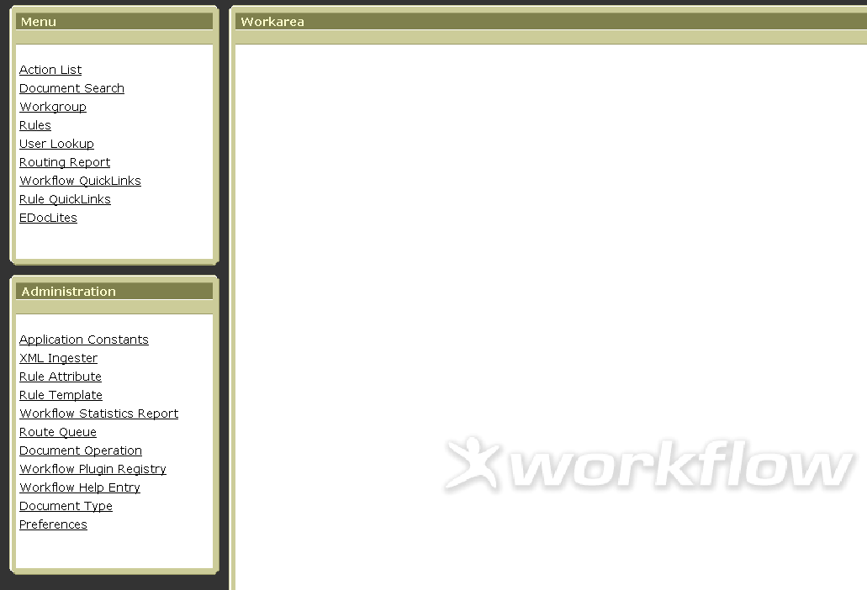
Figure 7-3 Administration group appears below the Menu group for Workflow Administrator users.

Table 7-2 Administration Group
Menu | Description
Application Constants | Create new / view existing application constant names and values.
XML Ingester | Browse for and upload XML data.
Rule Attribute | Enter criteria to search for rule attributes by Name, Class Name and/or Attribute Type.
Rule Template | Search for rule templates by Name or Description.
Workflow Statistics Report | Select date ranges and generate reports containing Users, Actions, Documents and Routing Status statistics.
Route Queue | View documents currently in the process of being routed.
Document Operation | Access and open a document by Document ID for the purpose of performing operations on the document.
Workflow Plugin Registry | View, Start, Stop and Reload the running of plug-ins by Plug-in Name.
Workflow Help Entry | Search for, customize and save online help screens according to the Help Name, Help Key and Help Text.
Document Type | Search for a document type by entering the following criteria: Parent, Name, Label, ID and/or Active/Inactive status.
Preferences | Select preference option settings that control the appearance of Action List and how automatic E-Mail Notifications are handled.

Route Levels
Documents route by progressing through a series of route levels. The e-doc supports both pre-established Workflow routing and Ad hoc routing.
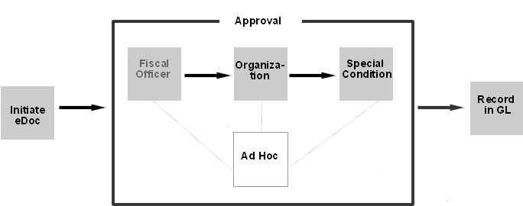
Figure 7-4 Workflow routes a document by matching attributes of a transaction to existing rules. Ad Hoc routing may occur at many points while the document is enroute.

Workflow Routing
In the Workflow routing, a document’s type (General Error Correction, Transfer of Funds, etc.) determines what route levels it passes through. Most, but not all, Kuali financial documents progress through the following route levels:

Account Level Routing (Fiscal Officer)
Each account in the KFS is assigned a Fiscal Officer, the designated approver called a Fiscal Officer. That individual is responsible for maintaining the fiscal integrity of an account and is often one of the first approver(s) to review a document that impacts that account. Documents are routed to the Fiscal Officer for each of the accounts identified in the document. For example, Sue is the Fiscal Officer for account 1012300. All financial transactions involving that account are routed to her for approval.

Organization Review (Review Hierarchy) Routing
Every account belongs to an organization. Customized routing to individuals or workgroups can be established by each organization based on criteria such as document type and dollar amount. This routing can take advantage of the Chart of Accounts Organization Hierarchy, meaning that approvals can be set up at different levels in that hierarchy. A document proceeding through Organization Review routing might route to someone at the Department level, then route to someone else at that Department’s School or College, and might even continue routing to someone up to a campus or university level. Organization Review routing is very flexible and can be customized to be as simple or complex as needed. For example, the Dean of Biology wants to approve every Transfer of Funds document over $1,000 that involves an account reporting to his Organization.

Special Condition Routing
This is a blanket-term for additional route levels that might be triggered by various attributes of a transaction. They often represent special administrative approvals that may be required. They can be based on the type of document, attributes of the accounts being used, or other attributes of the transaction. Throughout this document you may see route levels that are not Fiscal Officer or Review Hierarchy routing collectively referred to as 'Special Condition Routing.' Understand that this is shorthand for a variety of different types of routing which are explained in the documents that use them.
For example, you may establish Sub-Fund routing that requires that a document using an Endowment account to be approved by a workgroup responsible for the Endowment; or you may establish Contracts and Grant routing that requires that a document using a grant account to be approved by a central Contract and Grant Administration area.

Ad Hoc Routing
Ad hoc routing allows a document initiator or approver to add additional individuals or workgroups to the routing of a specific document. Ad hoc approvers inserted into the routing interrupt the regular routing process. For example, when a user initiates a financial document and ad-hoc routes it to his supervisor for approval, it routes to the supervisor before it routes to the Fiscal Officer.
Ad hoc Acknowledge and FYI routing do not ‘interrupt’ the regular routing process. Documents with these types of Ad hoc routing still pending are to post to the General Ledger once all other approvals are obtained. They are not held for the acknowledgement to take place or for the FYI to be cleared.
The following steps describe how to add an Ad hoc recipient in the Ad Hoc Recipients tab.
  - Select an action requested from the Action Requested list.
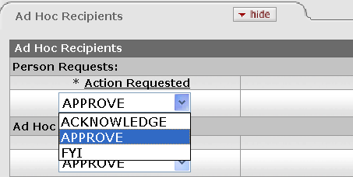
Figure 7-5 Select an action from the Action Requested list.
  - Enter a user ID in the Person input box or a Workgroup ID in the Workgroup input box, or use the lookup icon to select the appropriate user or workgroup name.
- To ad-hoc route the document to another person, type the username in the Person box in the Ad Hoc Recipients tab or use the lookup icon to search for the appropriate username.
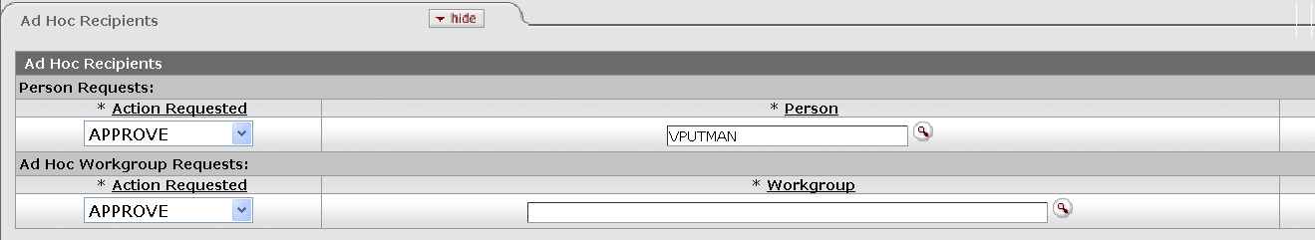
Figure 7-6 Ad-hoc route the document to another person.
- To ad-hoc route the document to a workgroup, type the workgroup name in the Workgroup box in the Ad Hoc Recipients tab, or use the lookup icon to search for the appropriate Workgroup name.
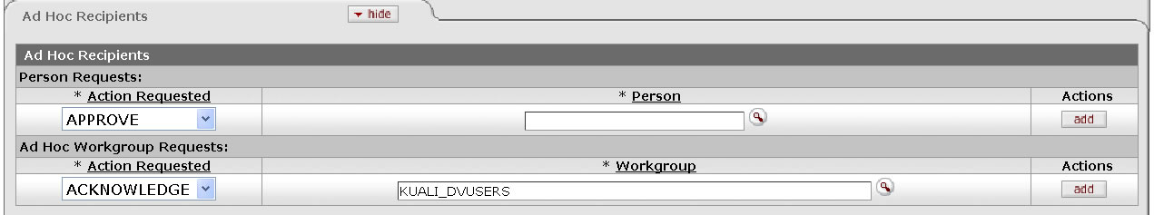
Figure 7-7 Ad-hoc route the document to a workgroup.
  - Click add.
The add button verifies that the User ID or Workgroup ID that you have entered for routing is valid.
  - Click submit.

When you complete the Ad Hoc Recipient tab and submit the document, the route node shows “Adhoc routing” and the workflow status changes to “ENROUTE.”
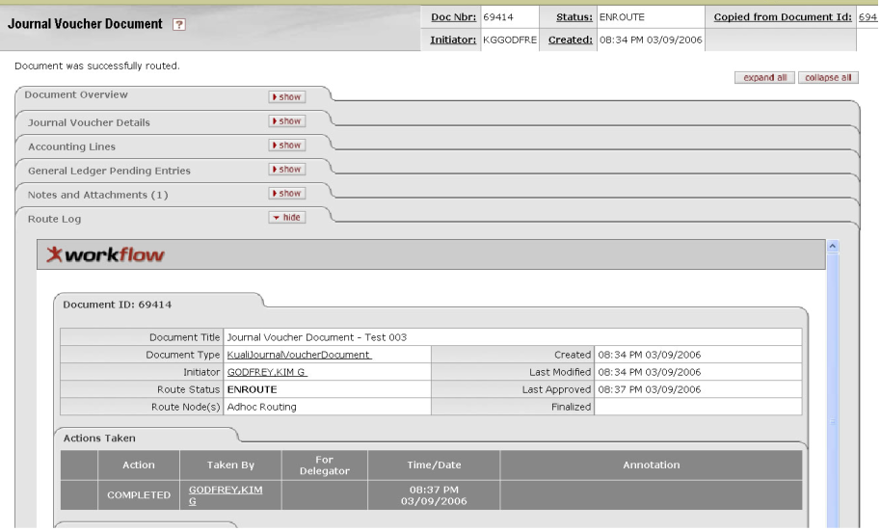
Figure 7-8 ENROUTE Status
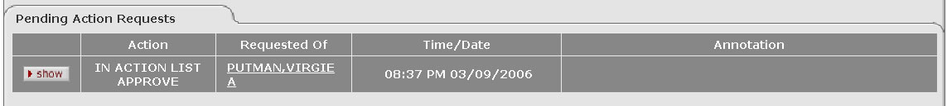
Figure 7-9 The Pending Route tab shows the requested action and the user ID that the document is now ad-hoc route to.

When you review the Route Log immediately after submitting a document, you may not see the Pending Action Requests tab within the Route Log. This is because the KFS has not yet received the routing information from Workflow. In this case, wait for a few seconds and click reload at the bottom of the screen to refresh the screen. You may need to repeat this process a few times until the information appears in the Pending Action Requests tab.
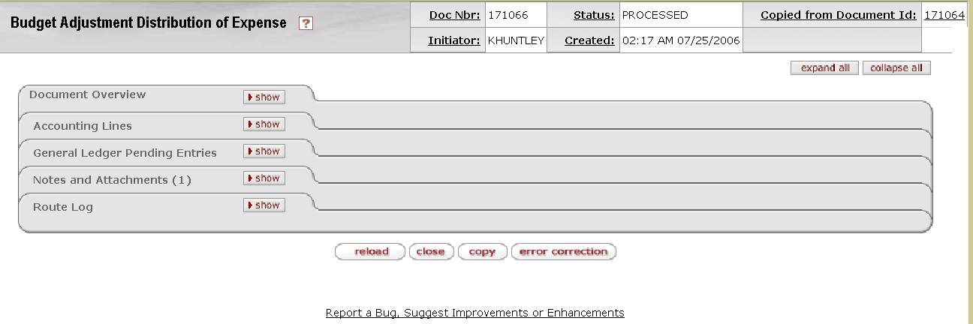
Figure 7-10 Click reload to refresh Route Log.

Viewing Route Levels
To see what route levels are associated with a particular document type, follow these steps:
  - Click workflow services.
  - Select Rule Quick Links
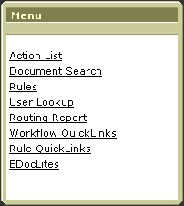
Figure 7-11 Select Rule QuickLinks from the Menu group.
  - Document types appear in the QuickLinks hierarchy.
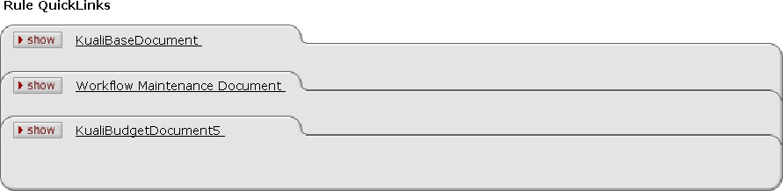
Figure 7-12 Rule QuickLinks
  - Click show to expand the tab.
For example, click the KualiBase-Document tab.
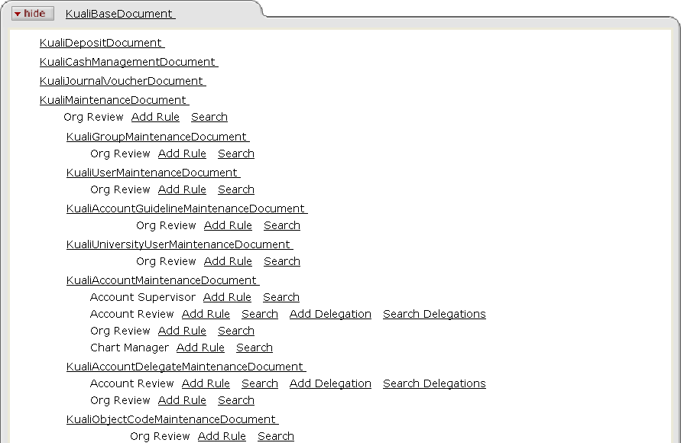
Figure 7-13 Expand the tab to see details.
  - Locate the desired Document Type route levels.
For example, scroll down to KualiTransferOfFundsDocument to view the rules of the Transfer of Funds document route levels.
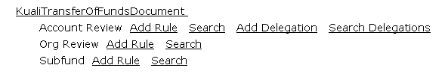
Figure 7-14 KualiTransferOfDocument Route Levels
The document routs through these levels in this order from top to bottom. You can view more detail about the types of routing rules established at a particular route level by clicking the Search link.
Figure 7-15 Click the Search link to view details.
  - Click search to retrieve the detail.
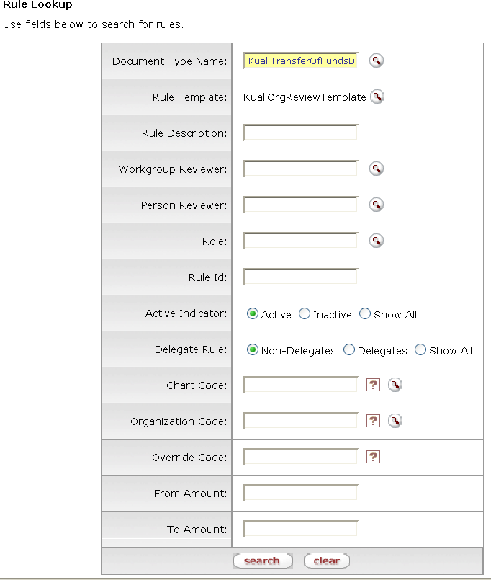
Figure 7-16 A Rule Lookup appears in a separate window.
  - The lookup results are displayed in the report format.
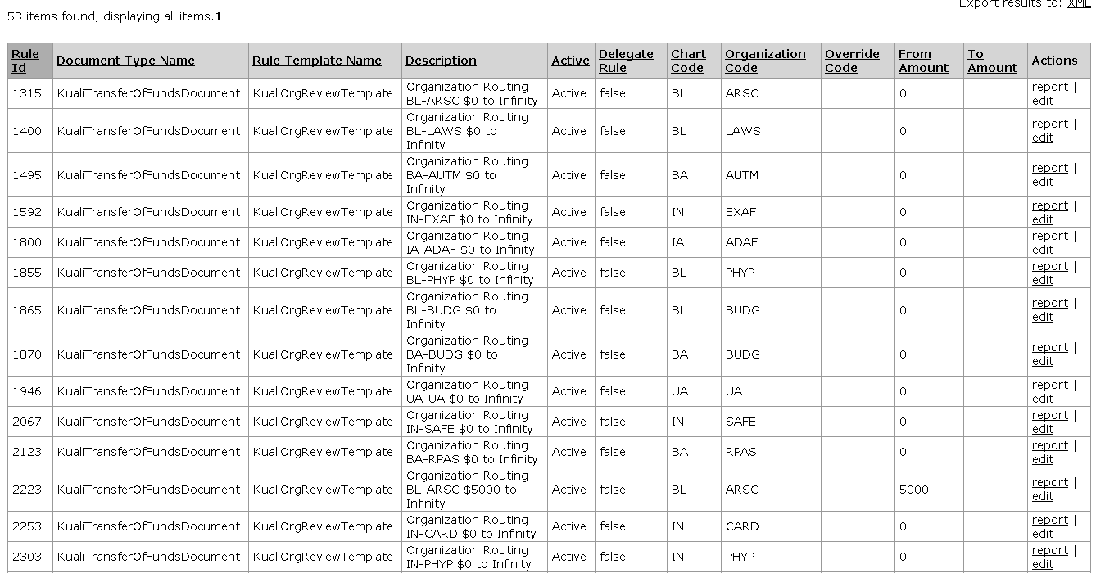
Figure 7-17 The route level rule details are retrieved.

Routing Rules
When a document routes through a particular route level it is evaluated against the rules that exist at that level. A rule acts like a trigger; if the criteria are met, an action request is sent to a particular user (or group of users).
Sometimes rules are established centrally (for example, the Account Review rule that says Fiscal Officers must see and approve documents affecting their accounts). Rules may also be established by end-users. A Departmental user may add additional approvers to the Org Review level of routing. Regardless of who adds a particular rule, the process is the same. Rules are added by completing a rule document (using the Add Rule link seen above). This document must also route and be approved, just like any other transaction.
As mentioned above, you can use the Search link on the Rules QuickLinks screen to search for rules for a particular document and at a given level.
You can view the details of the rule that caused the document to route to a certain person or workgroup from the Route Log. To find this information, click show next to the Action Request in the Route Log.

Route Log
The Route Log tab displays the workflow status details. The Route Log is broken into three tabs – the Document ID tab, the Actions Taken tab and the Pending Action Requests tab.
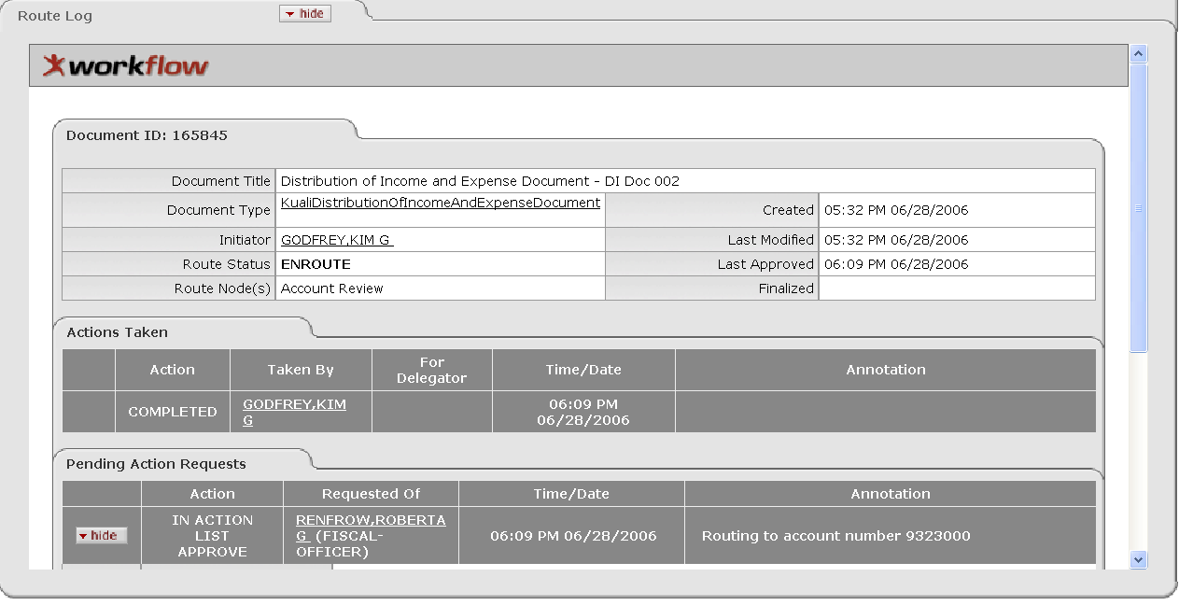
Figure 7-18 The Route Log tab displays the workflow status and actions previously taken.
Table 7-3 Route Log Tab
Title | Description
Document Title | A combination of the document type, description and the organization document number
Document Type | Type of financial transaction. The full name of the transaction used to identify this document type in Workflow
Initiator | The user ID of the person who created the document
Route Status | Workflow document status
Route Node(s) | The steps that a document takes through the different levels of routing are also referred to as 'Route Nodes.' This field shows the current Route Node of the document.
Created | Time and date that the document was created
Last Modified | Time and date that the document was modified last
Last Approved | Time and date that the last action was taken on this document
Finalized | Time and date that the document reaches Final, Canceled, or Disapproved status

For information about the route status, see “Route Status” in this chapter, page 26.

Action Taken Tab
The Action Taken tab displays the history of workflow actions on the e-doc. The tab shows what action was taken, who took the action, and the time and date the action was taken.
The For Delegator field shows the name of the Fiscal Officer if the person who has taken the action is a Delegate acting on that Fiscal Officer’s behalf. The Annotation field displays anything the person taking the action added to the Routing Annotation box on the document prior to completing their action.
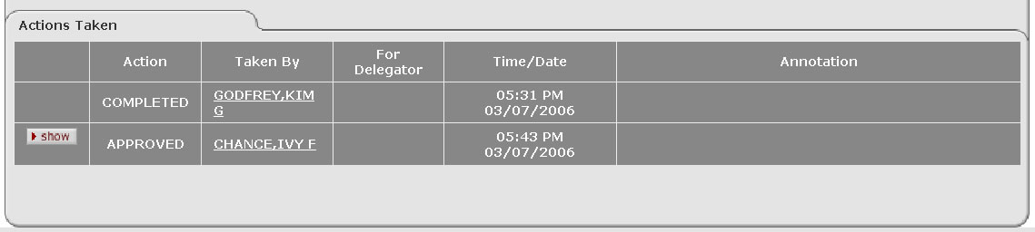
Figure 7-19 The Action Taken tab within the Route Log displays the workflow history.
You may drill down into the details of each action by clicking show.
Figure 7-20 You may drill down into the action taken detail by clicking show.

You may continue to drill down into the workflow action requestor information by clicking show.
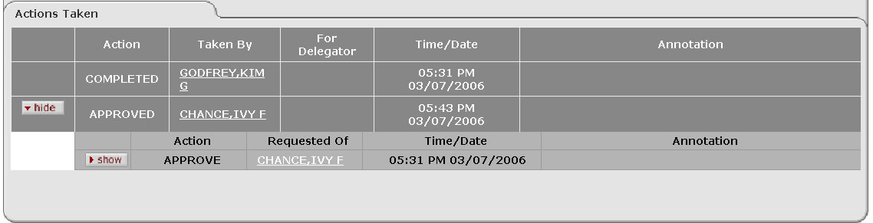
Figure 7-21 You may continue to drill down into the workflow action requestor information by clicking show.
You may drill down farther into the workflow system information by clicking show.
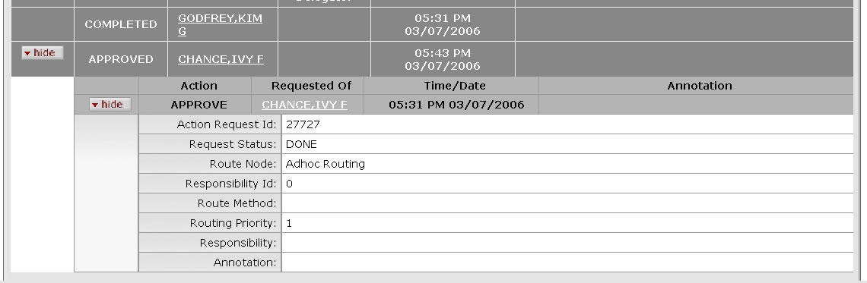
Figure 7-22 You may drill down farther into the workflow system information by clicking show.
There may be several layers of information available for a specific action request.

Pending Action Requests Tab
The Pending Action Requests tab displays the next action to be taken and reveals more detailed routing information about this request.

Viewing Pending Actions
The Requested Of field displays the user name or the workgroup based on the business rule set for the document being routed.
The following example shows a Cash Receipt document where the approver is a workgroup.
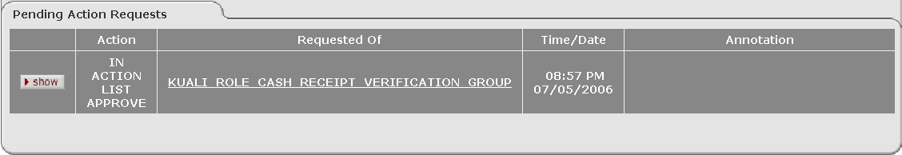
Figure 7-23 Pending Action Requests may show a workgroup.
The Action field indicates whether the document is in that user or workgroup’s action list or if it is pending their approval. Action requests of 'Pending Approve' mean Workflow has identified other approval actions needed at this route level, but has not actually sent the document for these requests yet. Workflow routing rules have a priority attribute that determines the order in which it sends action requests.
Note that the Pending Action Requests tab only shows pending requests for the document at its current route level (or Route Node). New requests may be added when the document transitions to a new route level.
Click the link for the workgroup to identify members of the workgroup. One of the members of this workgroup must approve the document to route it to the next step.

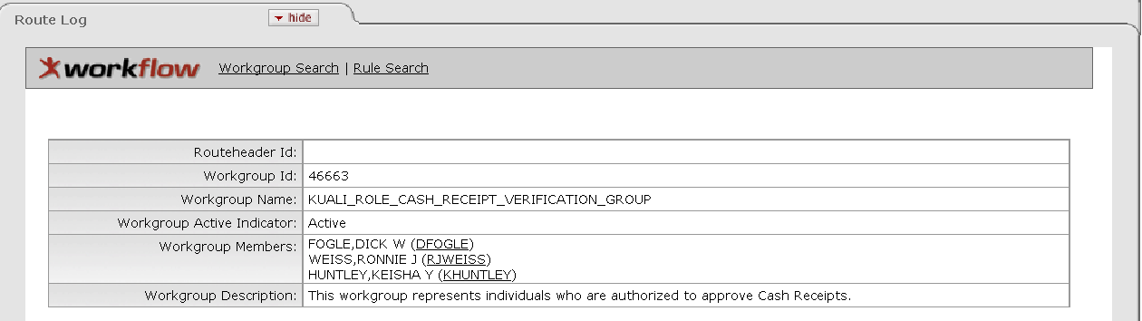
Figure 7-24 Click the workgroup hyperlink to see a list of the workgroup members.
Routing Annotation
You can enter any comments regarding the document into the Routing Annotation.
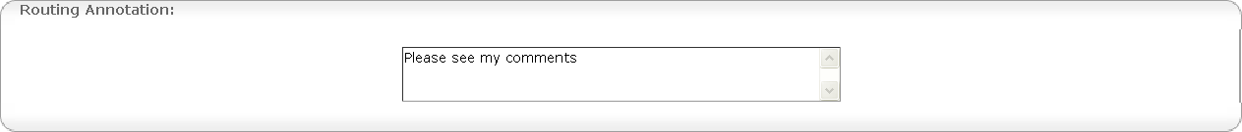
Figure 7-25 Entering notes in Routing Annotation
The annotation later appears in the Route Log tab. Unlike Notes entered in the e-doc Notes and Attachments tab, Routing Annotations are a part of Workflow and can be viewed at any time in the route log without accessing the e-doc itself.
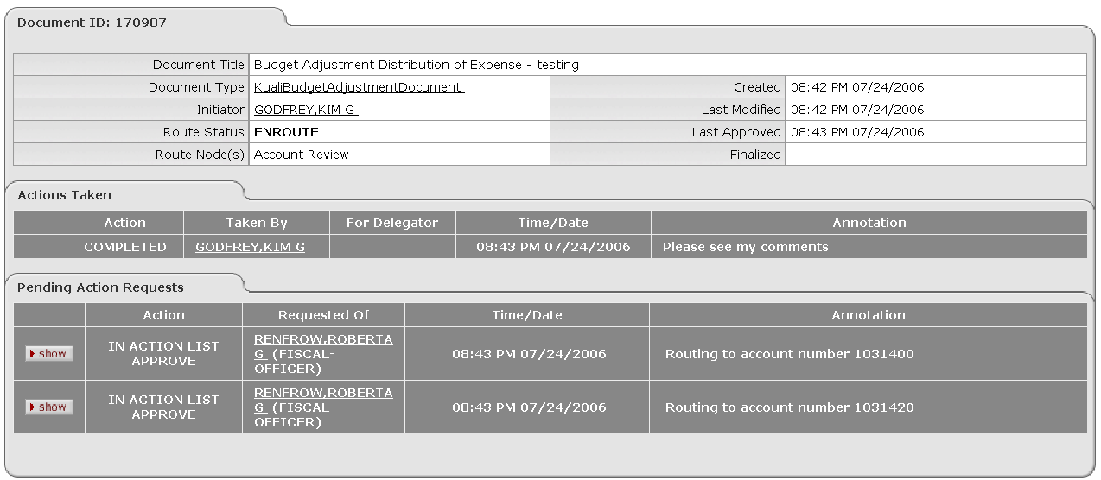
Routing annotation appears here
Figure 7-26 Routing annotations appear in the Route Log.

Viewing Rules
Clicking show reveals more detailed routing information about the request.
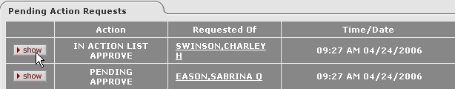
Figure 7-27 Click show to view detailed routing information.
To see the various criteria that make up this rule you can click the Rule link (for example, by clicking the hyperlinked 'Rule: 1315').
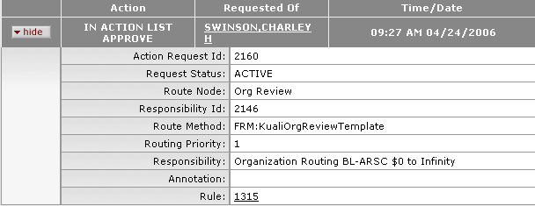
Figure 7-28 Click the Rule hyperlink to view the rule details.
In the General Info section, you are able to view basic identifying rule information as well as details about what makes the rule work.
Rules are specific to certain documents or groups of documents. For example, under Document Type you can see that this rule is specific to the Transfer of Funds document.
You create rules using a Template. The template establishes what kind of criteria (or attributes) the rule can look for. In this case, this rule is based on the KualiOrgReviewTemplate. This template is used to create Organization Review (also called Organization Hierarchy) rules.
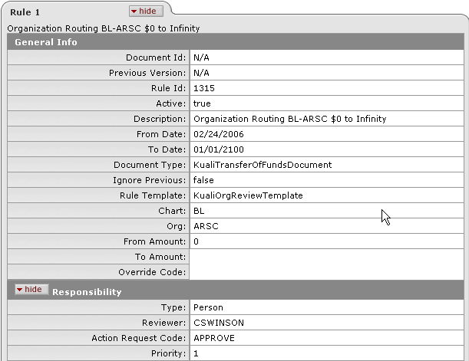
Figure 7-29 Viewing the Rule Details
In most cases, a rule works by comparing the content of the document to specified attributes of that rule. Near the bottom of the General Info section you are able to view attributes that this rule uses to determine whether or not a particular document applies to it:
Chart: | BL
Org: | ARSC
From Amount: | 0
To Amount: | (blank)
Override Code: | (blank)
This rule looks for Transfer of Funds transactions using an account that belongs to BL-ARSC (or that belong to Organizations answering to BL-ARSC). The remaining attributes indicate that this rule should look for documents of any dollar amount and any (or no) override code.

If a document meets the specified criteria then it routes based on information in the Responsibility section of the rule. For example:
Type: | Person
Reviewer: | CSWINSON
Action Request Code: | Approve
Priority: | 1
Type indicates whether you are requesting action from a person or a workgroup. In this example, the rule indicates a person.
Reviewer is the userID of the person or workgroup the action is being requested from.
The Action Request Code indicates the type of action being requested. Normally requests can be made for Approval, Acknowledgement or FYI.
Priority tells Workflow how to order action requests if it needs to generate more than one request for a specific document at this route level. Priority ranges from 1 to 11 and rules with a lower priority number assigned requests action before rules with a higher priority number.

Route Status
Route Status tells us where the document is in the routing process. The Route Status appears in the Route Log tab and also in the document header.
Figure 7-30 The Route Status is displayed in the Route Log.

The following table summarizes the meaning of the various route statuses in the KEW:
Table 7-4 Route Status
Status | Description
Approved* | The document is approved. The document is now a valid business transaction in accordance with institutional needs and policies.
Canceled | The document is denoted as void and should be disregarded.
Committed* | The document has been committed to the database.
Disapproved | The document is disapproved by an approver as a valid financial transaction.
Enroute | The document has pending approval requests.
Exception | The document has been routed to an exception queue because workflow has encountered a system error when trying to process a rule.
Final | The document has been routed and has no pending approval or acknowledgement requests. Documents in Final status are considered approved in that documents in this status impact the General Ledger or update Chart of Accounts values.
Initialized | The document is created.
Processed | The document has no pending approval requests but still has one or more pending acknowledgement requests. Processed documents are considered approved and impact the General Ledger or update Chart of Accounts values.
Saved | The document has been started but not completed or routed yet. The Save action allows the initiator of a document to save their work and close the document. The document may be retrieved from the initiator’s action list for completion and routing at a later time.

A user does not normally see the status. The only time those statuses might show is when there is a system error or performance issue.

Rule Templates and Attributes
As explained above, rules are built based on rule Templates. Templates represent a route level and a collection of attributes.
Attributes are the building blocks of Templates. They identify which components of a transaction can be used to establish routing rules. For example, in the Org Review Template above, the attributes were:
- Chart
- Org
- From Amount
- To Amount
- Override Code
Because the Kuali is a Community Source application (meaning it was developed for Higher Education as a whole), it is critical that Kuali Workflow allow flexibility in the creating of rules. Different institutions may wish to route transactions based on different attributes and have more or fewer route levels.
Templates can be designed by combining various Kuali attributes and configuring a Document Type (such as a Transfer of Funds or Budget Adjustment) to use that Template as one of its route levels. This gives a great deal of flexibility and puts routing changes within the grasp of functional users.
However, because they are critical to Workflow functioning properly, the creation and maintenance of Templates (and attributes) is restricted to Workflow Administrators.

KEW Operations
The following section explains some of the operations that a user should know in order to use the KEW.

Action List
You receive action requests for KFS transactions through your Action List. Summary information about the documents in your Action List is provided, such as Document Type, Title, Route Status, the type of action requested of you, who initiated the document, when it was created and whether or not you’ve received this request because you are a Delegate or a member of a workgroup.
  - Click action list.
The workflow system retrieves all of the documents that you have initiated and saved, and any documents that are routed to you to approve, acknowledge or FYI.
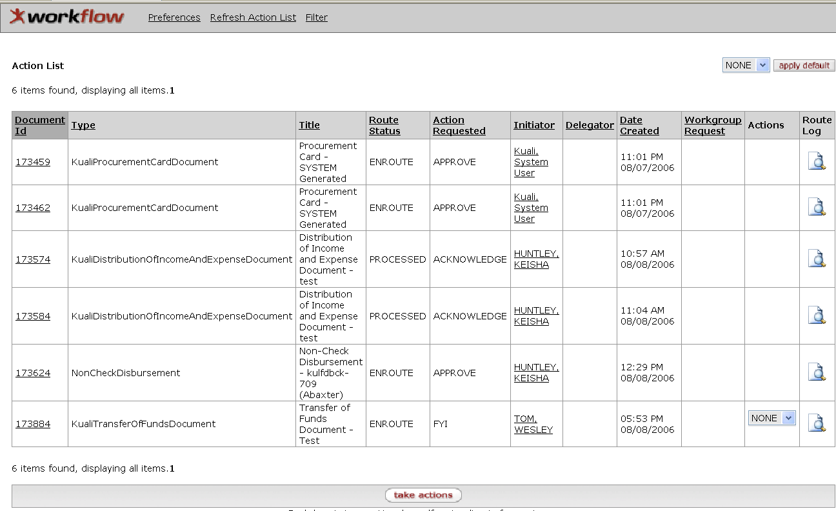
Click the document ID link to open the document
Figure 7-31 Documents in the Action List that are pending action.
  - Click the Document ID link to open the document.
  - Click one of the workflow action buttons.
A different set of buttons appears in the bottom of the screen depending on your roles and the requested action.
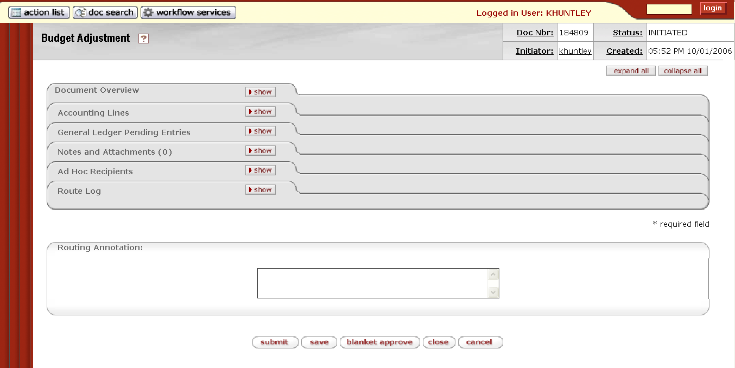
Figure 7-32 Workflow Action Buttons

Workflow Action Buttons
When a document is opened the user sees different workflow action buttons in the bottom of the document (Error: Reference source not found) depending on their relationship to the document and the document’s current workflow status. These buttons vary depending on what kind of action request you received for the document and on whether or not you are a special kind of Kuali user, such as an Administrator or Superuser.

Table 7-5 Workflow Action Buttons
Action | Description
Acknowledge | Signifies that the user has responded to the Acknowledgement action request. It is only available to users to whom a document has been routed for acknowledgement. See FYI.
Approve | Signifies that the document represents a valid business transaction in accordance with institutional needs and policies in the user’s judgment. A single document may require approval from several users, at multiple route levels, before it moves to final status.
Blanket Approve | Bypasses all subsequent levels of approval and immediately moves a document to final status. Anyone who would normally have received the document for approval receives an Acknowledgement request instead. This action may only be taken by an Administrator.
Cancel | Denotes that the document is void and should be disregarded. Canceled documents cannot be modified in any way and do not route for approval.
Close | Signifies that the user wishes to exit the document. The system displays a message asking the user if they want to save the document before closing. No changes to Action Requests, Route Logs or document status occur as a result of a Close action. If you initiate a document and close it without saving, it is the same as canceling that document.
Copy | Allows you to create a new document based on the existing document.
Disapprove | Signifies that the document does not represent a valid business transaction in the user's judgment. A Disapprove action from any single approver prevents a document from ever posting to the GL.
Error Correction | Allows you to correct documents by creating a new document that reverses the original transaction. This feature can only be used on documents that have completed the routing process and have been fully approved.
FYI | Signifies that the user has responded to the FYI action request. Only available to users to whom a document has been routed for FYI. The difference between Acknowledgement and FYI is that FYI requests can be cleared directly from the action list without opening the document. FYI requests also have a different effect on the document status than Acknowledgements. A document with no pending approval requests but with pending Acknowledge requests is in Processed status. A document with no pending approval requests but with pending FYI requests is in Final status.
Reload | Refreshes the screen and displays the most recently saved information. Changes which are made but not saved prior to reloading a page are not maintained.
Save | Allows the initiator of a document to save their work and close the document. The document may be retrieved from the initiator’s Action List for completion and routing at a later time.
Submit | Moves the document (through workflow) to the next level of approval. Once a document is submitted, it remains in Enroute status until all approvals have taken place.
Supervisor Functions | Allows superuser to take superuser actions such as adding annotation; Ad-hoc routing the document; approving, disapproving, or canceling the document; approving the document at a document route level or completing the pending action request. It only appears when the superuser retrieves the document that is in en route.

Special attention should be paid to the following when you select one of the workflow action buttons noted below:

Blanket Approving a Document
If you are an Administrator, you have the option to blanket approve a document routed to you for your approval. Click blanket approve to approve the document bypassing all other approvals.

Disapproving a Document
  - Click disapprove.
  - Enter a reason for disapproval, and then click yes to confirm.
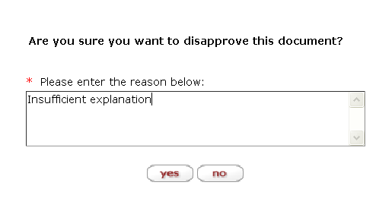
Figure 7-33 Enter a reason for disapproval.
  - The reason entered displays in the Notes and Attachment tab once the disapprove action is completed.
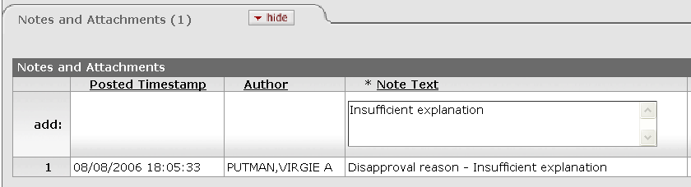
Figure 7-34 The reason for disapproval displays in the Notes and Attachments tab.

Acknowledging a Document
Click acknowledge. Acknowledgements do not interrupt the normal Workflow routing of a document. They do not stop a document from routing on to other individuals or workgroups who need to take approval actions.

FYI
FYIs do not interrupt the normal Workflow routing of a document either. To signify that you have responded to the FYI action, you may take one of the two actions: click FYI when you open the document, or select FYI in the Actions column and click take actions directly from the Action List (Figure 7-35).
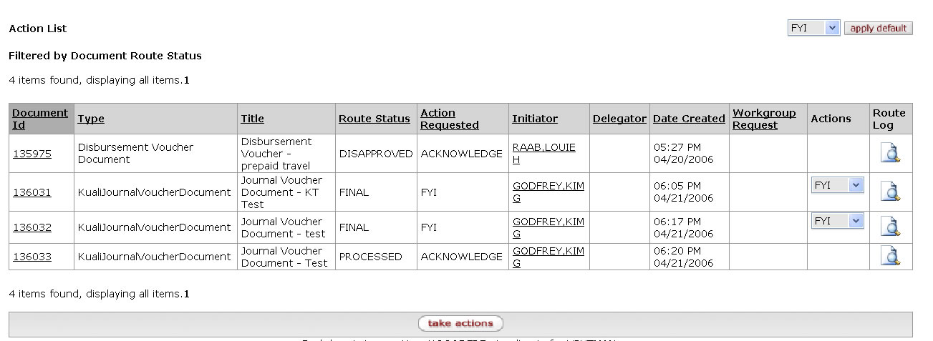
FYI
Take actions button
Figure 7-35 The Action List for FYI displays the Actions list.
Setting the default action for FYI
If you wish to clear all of the FYI actions in the Action List at once, you may first set the default action from NONE to FYI. Click apply default located at the upper right corner (Figure 7-35) and then click take actions.
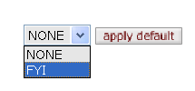
Figure 7-36 You can set the default to action to FYI in the Action list.

Correcting Errors after Approval
  - Click error correction.
A new document is created with a new document ID. Corrects Document ID is displayed in the Document Header, and also in the Notes and Attachment tab of the document.
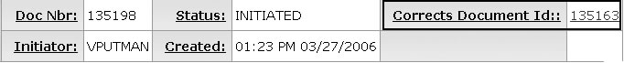
Figure 7-37 When you create a document using error correction, Corrects Document ID is displayed in the Document Header.
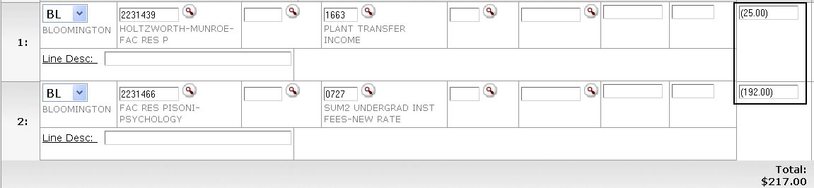
Figure 7-38 All figures in the Amount fields are shown negative to reverse the original transaction.
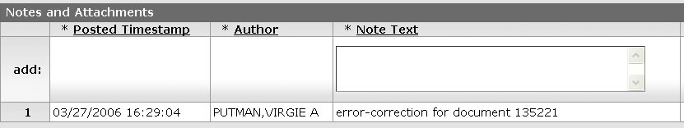
Figure 7-39 The new document has an annotation that is an error correction.
  - Make desired corrections to the document.
  - Click submit.
A document created with the Error Correction action must route and be approved in the same manner as the e-doc it corrects. The Error Correction action should not be confused with the financial transaction document type General Error Correction (GEC), which is described in Chapter 2.

Supervisor Functions
When a superuser retrieves a document, the Supervisor Functions button appears in the list of action buttons.
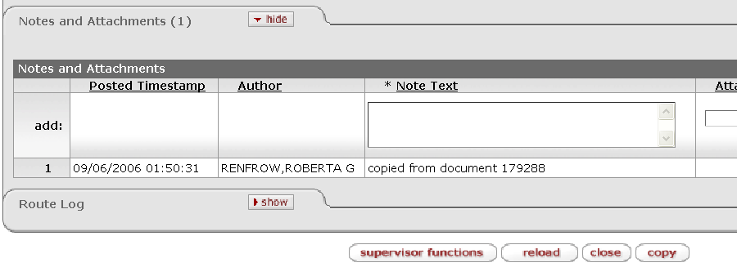
Figure 7-40 The supervisor functions button appears as one of the action buttons.
Clicking the supervisor functions button takes you to the document view with supervisor action buttons in the lower half of the screen. From that view, the superuser may take various actions that are only allowed for the superuser.
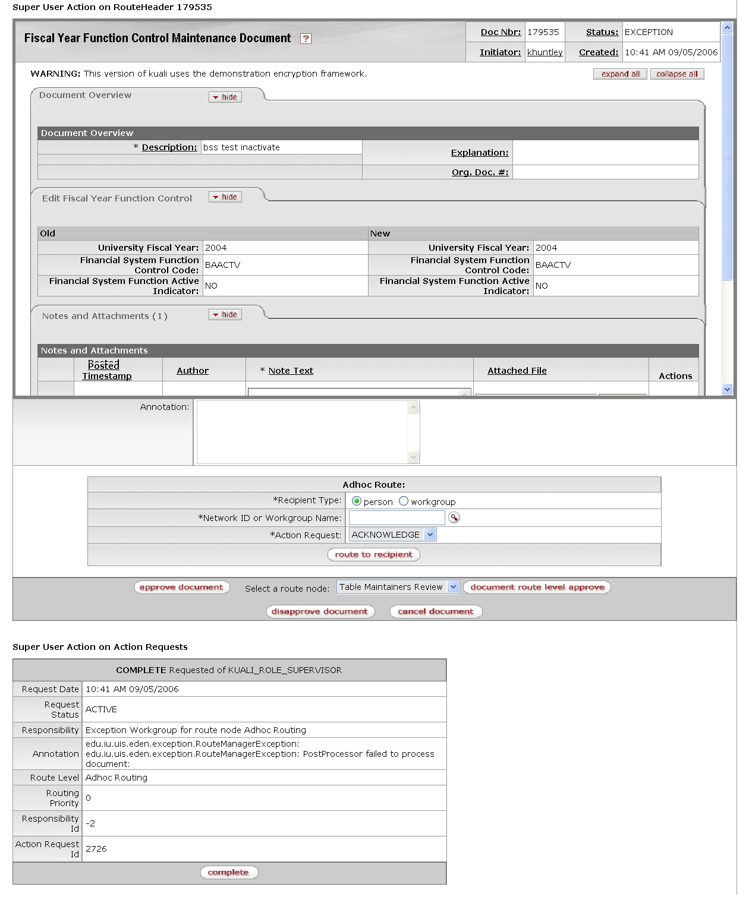
The superuser action buttons appear in the lower half of the document
Figure 7-41 Superusers may take special actions on the documents retrieved.

The following describes the actions that can be taken by the superuser.
To add annotation, enter the text in the Annotation box.
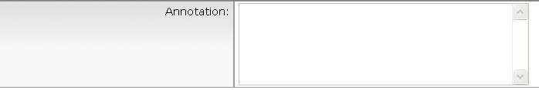
Figure 7-42 Superuser may add an annotation.
To ad-hoc route the document, select the recipient type, enter the user ID or workgroup ID, select the action request and click route to recipient.
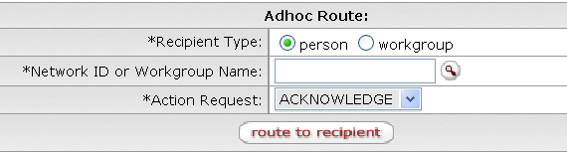
Figure 7-43 Superuser may ad-hoc route the document.
To approve a document, click approve document. To disapprove the document, click disapprove document. To cancel the document, click cancel document. To return the document to the previous route level, select a node name from the route level list and click return to previous route level.
Figure 7-44 Superuser may approve, disapprove, cancel, or return the document to previous route level.

To complete the requested action, you may click the appropriate action button which appears with the pending action request description.
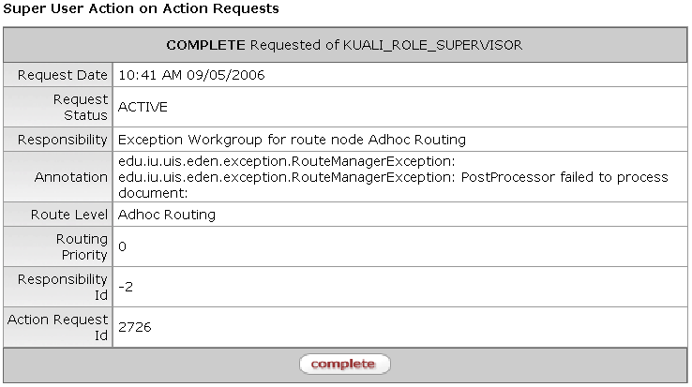
Figure 7-45 Superuser Action on Action Request
The superuser action button becomes available from the regular document search. However, superuser search is another way for superusers to go directly to those options. For information about the superuser search see “Detailed vs. Basic Search” in Chapter 7, page 47.

Action List Preferences
Click the Action List Preferences hyperlink to change the automatic refresh rate, action list page size, email notification, and row colors based on the status of the document. You may also limit the list of documents to display in the Action List by setting filters for delegators or workflow status.
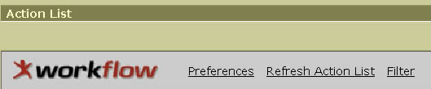
Figure 7-46 You may change the preferences for Action List from the Preferences hyperlink.
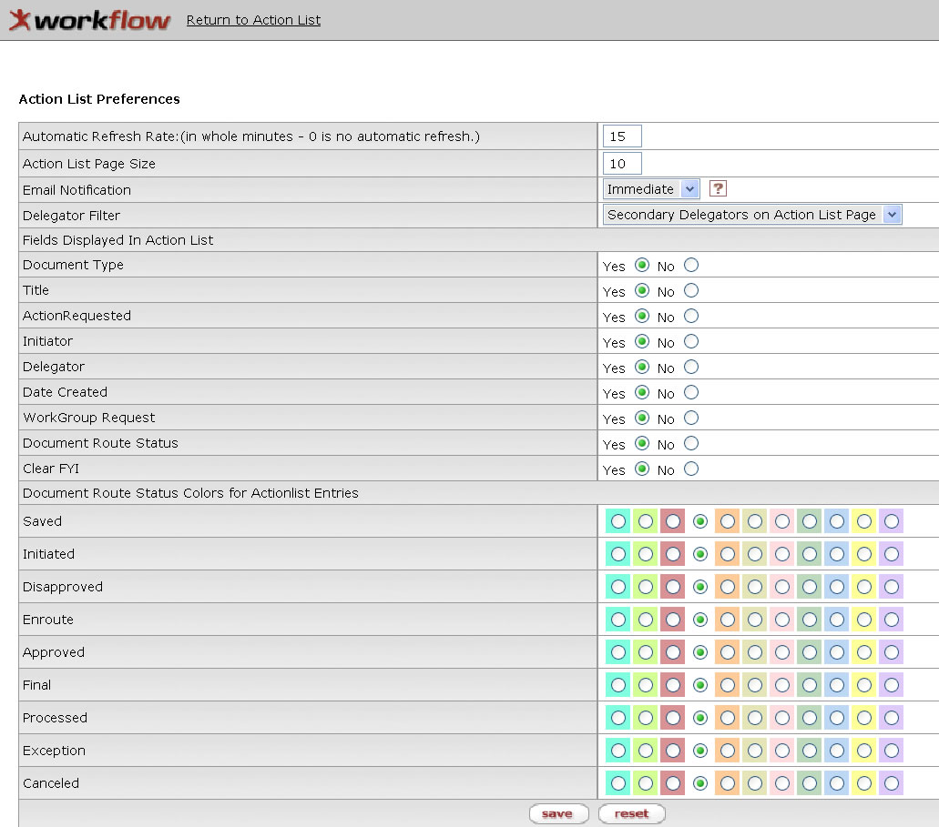
Figure 7-47 Action List Preferences allows you to change the display of your action list.
Table 7-6 Action List Preferences
Criteria | Description
Automatic Refresh Rate | Enter a number in whole minutes.
Action List Page Size | Enter a number of rows to display per page in the Action List.
Email Notification | Select one of the desired email frequencies from the Email Notification list of None, Daily, Weekly or Immediate.
Delegator Filter | In the Delegator Filter list, click Secondary Delegators on Action List or Secondary Delegators only to specify when to show the secondary delegation entries in your Action List.
Fields Displayed in Action List | Click either Yes or No for each of the fields to be displayed in the Action List.
Document Route Status Colors for Action List Entries | Click one of the color options for each of the Document Route Status. The row containing the document of the status is displayed in the color of your choice in the Action List.

To save your preferences, click save.
Click reset to return to the default preferences.
The effect of the color preference change does not take place until you log onto the system the next time.
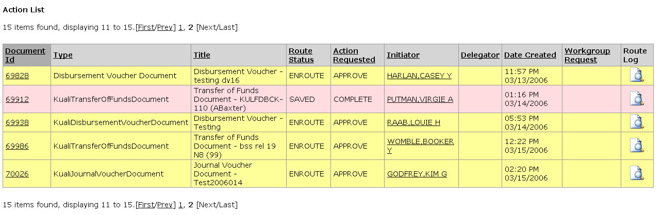
Figure 7-48 The row colors change the next time you logon after changing the Action List Preferences.

Action List Filter
Setting a filter allows you to display a subset of the Action List. Click the Filter hyperlink to go to the Action List Filter dialog box.
Figure 7-49 Click Action List Filter hyperlink to go to the Action Filter dialog box.

  - Specify the filtering criteria in the Action List Filter dialog box.
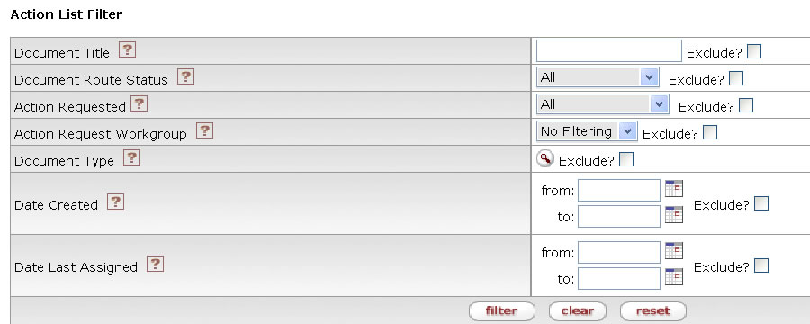
Figure 7-50 You may limit the e-docs displayed in your Action List by setting a filter.
Table 7-7 Action List Filter
Criteria | Description
Document Title | Enter a partial or full character string that you are looking for in the document description. For example, when you enter 'Test' in the Document Title field, the Action List displays all documents that contain 'Test' in the document description. This field case sensitive.
Document Route Status | Select a route status in the Document Route Status list. The list contains the choices All, Approved, Disapproved, Enroute, Exception, Processed and Saved. Select the Exclude? check box to exclude documents with the selected status from the list.
Action Requested | Select an action in the Actions Requested list. The list contains Acknowledge, Approve, Disapprove, and FYI. Select the Exclude? check box to exclude documents with the selected action from the list.
Action Requested Workgroup | Enter the name of the Workgroup that is requested to take an action.
Document Type | Select a document type from the Document Type lookup .
Date Created | Enter a date range or select dates from the calendar by clicking the Calendar to limit the documents based on the date they were created. Select the Exclude? check box to exclude documents that were created during this given time range. The acceptable format is mm/dd/yyyy.
Date Last Assigned | Enter a date range or select dates from the calendar by clicking the calendar icon to limit the documents based on the date that this action item was generated for you. Select the Exclude? check box to exclude documents that entered your action list during this given time range. The acceptable format is mm/dd/yyyy.

  - Click Filter.
  - A system message appears in the upper left corner.
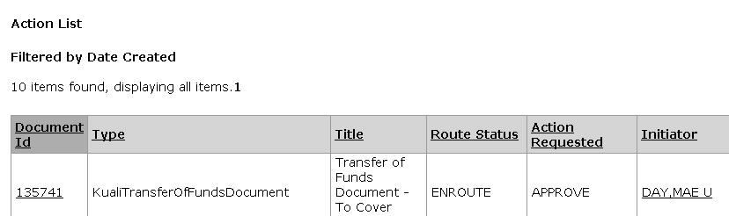
Figure 7-51 A filter message is displayed when you create a filter in the Action List.

Clearing Filter
Click Clear Filter to remove the filter. Note that the Clear Filter hyperlink is visible only when you have previously created the filter.
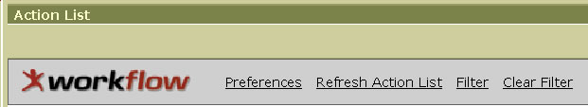
Figure 7-52 Click Clear Filter hyperlink to remove the Action List filter.

Refreshing Action List
Click Refresh Action List to display the complete Action List.
Figure 7-53 Click Refresh Action List to view the complete Action List.

Document Search
In the Chapter 2, we introduced the basic search capabilities within the KEW. The more advanced and sophisticated search capabilities are explained in the following section.
For information about the basic Document Search, see “Error: Reference source not found” in Chapter 2, page Error: Reference source not found.

Detailed vs. Basic Search
The search screen initially defaults to a basic search. You may switch between the basic search and detailed search by clicking the Basic Search or Detailed Search hyperlink. The detailed search screen gives you more options for search criteria.
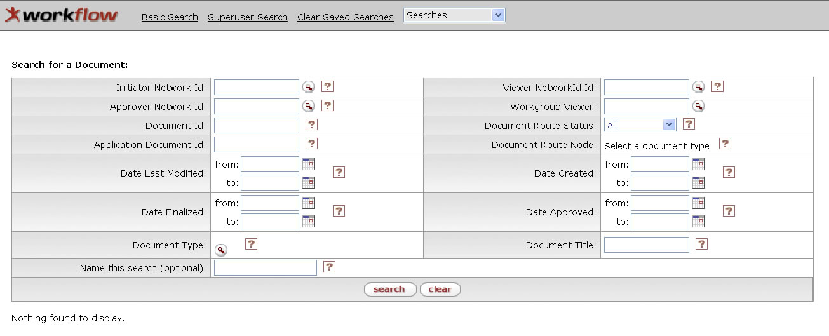
Figure 7-54 You may change the search mode by clicking the Detailed or Basic Search hyperlink.

Superuser vs. Non-Superuser Search
The search screen initially defaults to a Non-Superuser search mode. If you have the Superuser role, you may switch between the Non Superuser search and Superuser search mode by clicking the Superuser Search or Non Superuser hyperlink.
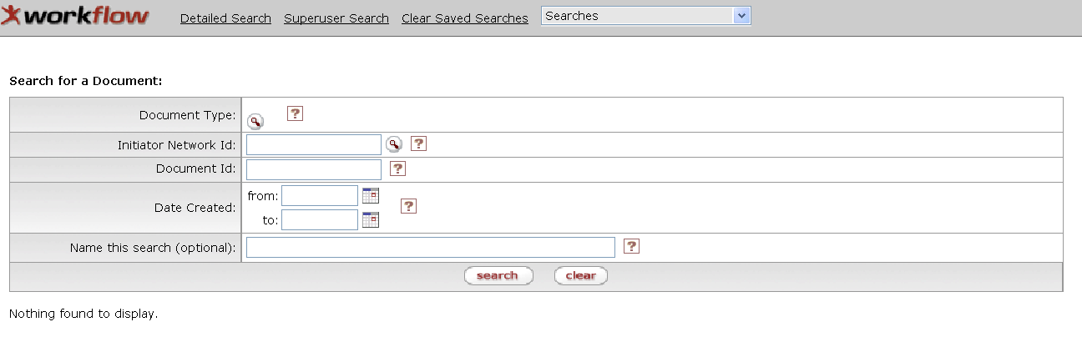
Figure 7-55 The Superuser Search mode gives you more search options.
The Superuser search mode gives you more search options and allows you to access documents you wish to take Superuser actions on, such as bypassing an approval or sending a document to another route level. Anyone can search for documents using Superuser search, but only Superusers can actually take special actions on the documents retrieved from the Supervisor search hyperlink.
For more information about supervisor functions, see "Supervisor Functions” in this chapter, page 37.

Named Search
When you name a set of search criteria, the system saves your search as a named search. When you later click search, the system displays a list of all named searches you have created in the Searches list.
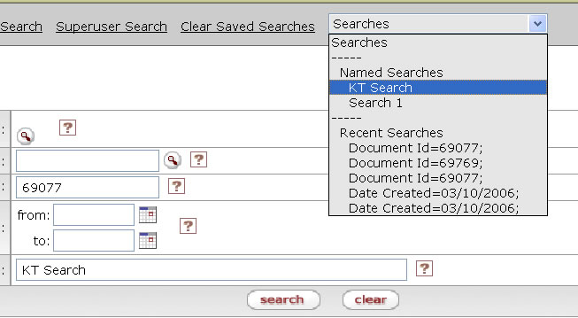
Figure 7-56 You may access your named search in the Searches list.

Clear Saved Searches
Click Clear Saved Searches to clear the named searches. The KFS clears the Searches list.
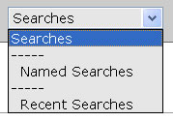
Figure 7-57 After clicking Clear Saved Searches, the Searches list no longer shows the previous saved searches.

Clearing Search
Click clear to clear your previous search criteria.

Summary
This chapter introduced to the basic concept of Kuali Enterprise Workflow (KEW) and some important features necessary to function as a KEW user. Topics covered included how to use the Action List and Workflow Action buttons; how to use advanced document search; how to analyze route status and routing rules. You also learned how to use the Route Log to reveal detailed information about the workflow rules.

